|  |  |
| --- | --- |
| C:\Users\ccomputer\Desktop\aalogo1.jpg | **Alumni Association**  **of**  **Government College of Engineering, Aurangabad**  **(AAGECA)**  **c/o Govt. College of Engg. Aurangabad, Osmanpura, Station Road, Aurangabad- 431 005**  **Website:** [**www.gecaalumni.org**](http://www.gecaalumni.org) **Email:** [**gecaalumni555@gmail.com**](mailto:gecaalumni555@gmail.com) |

**Report for SAT activities conducted for year 2021-22**

The academic year 2021-22 at Government College of Engineering, Aurangabad, was marked by several significant events. On July 27, 2022, the Batch of 1972 celebrated their Golden Jubilee at the IT Seminar Hall. Alumni and their spouses were warmly welcomed with roses at 9:00 AM. The day began with a formal address, followed by speeches and presentations that revisited the past 50 years, highlighting the achievements of the graduates and the institute. After lunch, a nostalgic tour of the campus allowed attendees to revisit familiar landmarks and departments significant to their academic journey. The event concluded at 6:00 PM with a closing ceremony, providing a joyous homecoming for the alumni to reconnect with their peers and faculty.

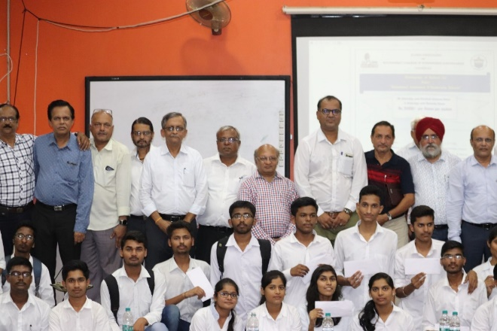 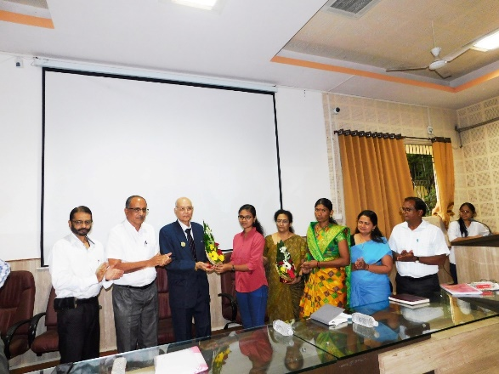

On September 15, 2022, the college felicitated Miss Vaidehi Pathak as the Best Outgoing Student for the academic year 2021-2022. The event was attended by faculty, staff, students, and distinguished guests. The college principal opened the ceremony with a speech emphasizing the importance of celebrating student achievements. Miss Pathak was recognized for her leadership and dedication. Shri M.B. Patney, the award sponsor, presented her with a gold medal and a cash prize of Rs. 51,000. In her acceptance speech, Miss Pathak expressed gratitude to her teachers, classmates, and family, emphasizing perseverance and hard work. The ceremony concluded with a reception, underscoring the college's commitment to nurturing talent and fostering a culture of excellence.

On November 30, 2022, the college hosted the inauguration of the SAT program and the felicitation of academic toppers. The SAT program aims to enhance student preparedness for standardized tests. The principal’s opening address highlighted the importance of the SAT program. Following the inauguration, top-performing students from various departments were honored. Eighteen students were felicitated from the second, third, and final years. Each topper received certificates and prizes from the chief guest, who congratulated them and encouraged their pursuit of excellence. The event celebrated both the launch of the SAT program and the remarkable achievements of the students.

On December 1, 2022, the college hosted a Personality Development Program led by motivational speaker Shri Rakesh Chanchalani. Known for his engaging style, Shri Chanchalani covered topics such as effective communication, self-confidence, time management, and goal setting. The program included interactive discussions, activities, and role-plays. Shri Chanchalani emphasized self-awareness and continuous improvement, urging students to embrace challenges and strive for excellence. The program received positive feedback, leaving attendees inspired and equipped with practical tools for personal and professional growth.

On January 22, 2023, the Alumni Association of Government College of Engineering Aurangabad (AAGECA) organized an industrial visit to Metarolls Steel Industry in Jalna for Civil and Electrical Engineering students. Forty-seven students and faculty members participated, gaining practical exposure to industrial processes relevant to their studies. The visit began with an overview of the company’s operations and safety guidelines, followed by a guided tour through various departments. Students observed the steel production process and engaged in interactive sessions with industry experts, gaining insights into technical aspects, quality control, and environmental sustainability practices. The visit provided a comprehensive understanding of the steel manufacturing industry, enhancing students' theoretical knowledge with practical experience, and inspiring them to explore potential careers in the industrial sector.